Monolithic model:

* Test whole application every time the code changes
* When spikes in website traffic servers can be scaled up but all the other functionalities are also scaled up

Modular application development: All parts of code installed onto one machine

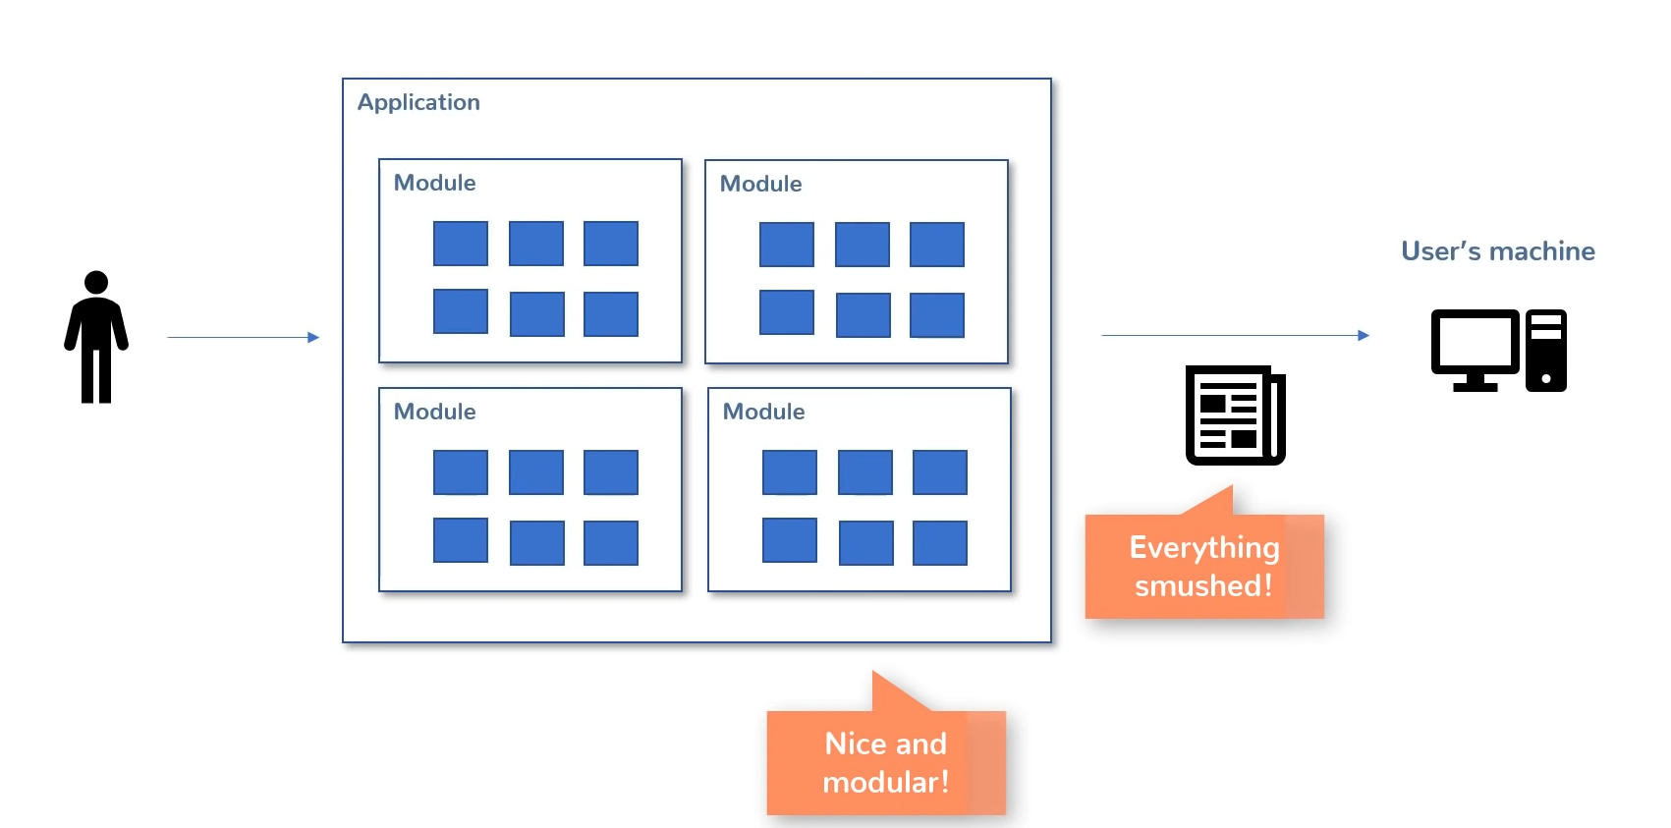

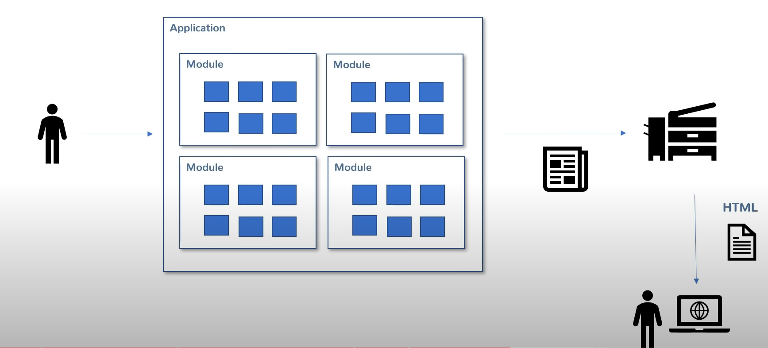

Microservices:

* Call each other REST api to use services
* Work together to be one application
* Flexible
* Can be scaled separately
* Discovery server
  + Client side (Client does call to discovery server to ask where the service is then it calls te correct service) (Eureka)
  + Server side (Call gets made to discovery server and it connects call directly to correct service) (NGINX, AWS)

